USC Air Powered Rover

Subject:Physics, Electronics  Related Subjects: Mechanical Engineering | Grade Level(s): 6 - 8  Length of Lesson: 65 Minutes | Type: Project  Keywords: Series circuit, Axle, Chassis, Alignment, Horsepower (torque x rpm), Suspension

Lesson Overview
Students will build an air-powered rover using simple household and electronic components. This project demonstrates how energy from a motor-driven propeller can propel a lightweight vehicle forward.
Students will then test cars for speed, distance and endurance.
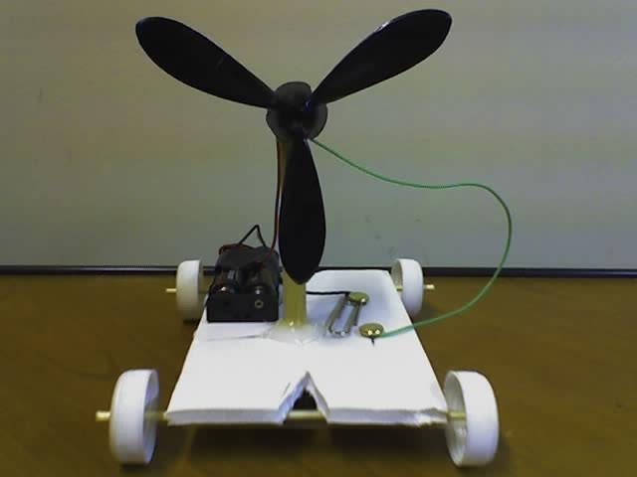

Lesson Focus
How can stored electrical energy be converted into kinetic energy to power a rover?
Lesson Objective(s) | - Build suspension (wheels and axles) from bottle caps, foam core and wood dowels.  - Build chassis from foam core.  - Create series circuit with motor, battery holder and switch  - Assemble a USC rover.  - Determine which design leads to better performance in  - Speed  - Direction  - “Off road” conditions  - Demonstrate trade-off of beauty versus function

Lesson Timing

10 minutes | Introduction and discussion on energy conversion
20 minutes | Suspension and chassis assembly
25 minutes | Wiring and motor setup
15 minutes | Testing, iteration, and wrap-up

Materials | - Foam board (3.5” x 5”) – Staples  - Wood skewers – provided by USC MESA  - Two straws – provided by USC MESA  - ⅜” wood dowels (one 3 inches) – www.kelvin.com – item # 850621  - Four caps from small water bottles – collect  - 1.5V motor – www.kelvin.com item # 850646  - Battery holder (double AA battery holder) – www.kelvin.com – item # 220090  - Two AA battery – from any retail store  - Brass plated fasteners (1 inch) – Staples  - Insulated wire – from www.kelvin.com – item # 330208  - Hot Glue gun – provided by USC MESA  - Hot glue sticks – Home Depot  - Large paper clips – Staples  - Wire stripper – provided by USC MESA  - Xacto knife or utility knife (to cut foam board) – Staples  - Drill – provided by USC MESA  - Propeller – www.kelvin.com – item # 850891
Instructor Prep | - Pre-cut foam boards (optional for younger students)  - Pre-drill bottle cap holes  - Organize tools and materials for easy access  - Test one completed rover as a demonstration model
Related Resources | - Homemade Propeller Car - ResearchParent.com  - Electric Fan Car Project for Kids - STEM Classic Made Better : 7 Steps (with Pictures) - Instructables

Lesson Plan

Introduction
Anyone who has been on a bike or in a stick shift car has felt the effects of gearing and mechanical advantage causing motion. Some energy source (your legs or a motor) causes an object to turn. That object turns another object causing the vehicle to move forward.

Discuss how different forms of energy (electrical, mechanical, kinetic) can work together. Prompt students with a real-world connection: How do fans and propellers generate thrust? What powers rovers like NASA’s Perseverance?

Procedure
Instructions for Suspension and Chassis

- Cut a rectangle from the foam core (about 3.5” x 5”).
- Cut two ½” slits into the foam core parallel to the side railings (about 2” from one of the railings and about 1” apart)
- Cut two straws about 3.5” (the width of the foam core)
- Drill a hole in the middle of each of the four water bottle caps (the circumference smaller than the circumference of the wood skewer)
- Glue the two straws to foam core parallel to the 3.5” sides and about ½” from both sides
- Insert one end of the skewer into one of the water bottle caps. Insert axle into the straw. And insert the other end of the skewer into the second water bottle cap. Cut excess skewers.
- Repeat above for the second axle.

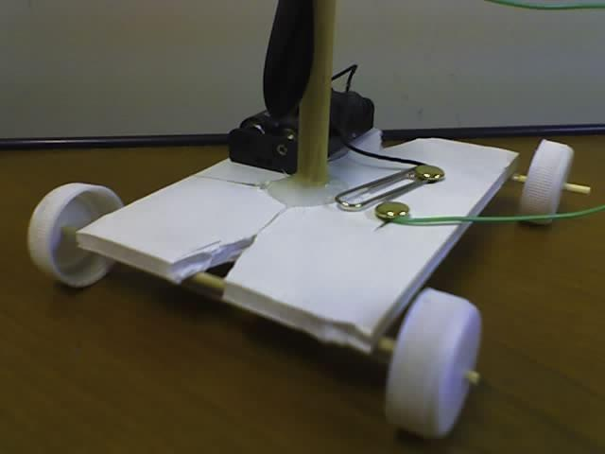

Instructions for battery-powered Propeller

- Cut and strip one piece of wire (about 6”).
- Strip both wires of a battery holder.
- Insert one end of the 6” wire to one lead of the motor.
- Insert one wire of the battery holder to the second lead of the motor.
- Tape both wires to the motor.
- Using the other end of the 6” wire, insert stripped wire between the legs of a brass fastener and secure it. Insert the brass fastener with wire into one of the slits and fasten to the foam core.
- Using the other wire from the battery holder, insert the stripped wire between the legs of another brass fastener and secure it. Insert brass fastener into paper clip, insert into second slit, and fasten to foam core.
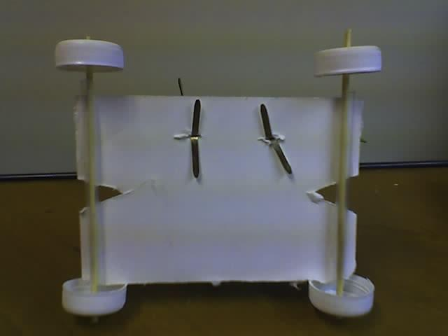

- Attach propeller to the stem of motor
- Test circuit with batteries.
- Cut one ⅜” piece of dowel with length of 3”.
- Glue motor with attached propeller to one end of the dowel.
- Glue the other end of the dowel to the middle of the foam core.
- Glue battery holder to foam core.

Wrap-up
Discuss what worked and what didn’t. Ask:
- What changes improved your rover’s performance?
- How do motor placement and weight affect speed?
- What real-world vehicles use similar propulsion?
Cleanup: Dispose of wires and foam scraps responsibly.

Lesson Background for Teachers

Suggested Real-World STEM Connections
Rovers are typically created to land on another planet (other than Earth) via a lander-style spacecraft, tasked to collect information about the terrain, and to take crust samples such as dust, soil, rocks, and even liquids.
Opportunity was the second of the two rovers launched in 2003 to land on Mars and begin traversing the Red Planet in search of signs of ancient water. The rover explored the Martian terrain for almost 15 years, far outlasting her planned 90-day mission.
The rovers were planned as 90-day missions to search for geological clues regarding environmental conditions on early Mars, and assess whether those environments were conducive to life.

After landing on Mars in 2004, Opportunity made a number of discoveries about the Red Planet including dramatic evidence that long ago at least one area of Mars stayed wet for an extended period and that conditions could have been suitable for sustaining microbial life.
The Opportunity rover stopped communicating with Earth when a severe Mars-wide dust storm blanketed its location in June 2018. After more than a thousand commands to restore contact, engineers in the Mission Control at NASA's Jet Propulsion Laboratory (JPL) made their last attempt to revive Opportunity Tuesday, February 13, 2019, to no avail. The solar-powered rover's final communication was received June 10.
Source: Mars Exploration Rovers: Spirit and Opportunity - NASA Science, Mars Missions - Opportunity Rover

Lesson Variations and Options
- Add a switch to the circuit
- Change propeller size to test thrust differences
- Race rovers to test speed and weight influence
- Build using recycled materials only

Explanation
The suspension of the rover comprises two straws, two wood skewers and four small water bottle caps. Each wood skewer is inserted lengthwise through the straw with a foam core wheel base attached to each of the straws. A tight suspension involves a tight fit through the foam core base for the dowel. A loose suspension allows wiggle room for the dowel inside the foam core base.
The chassis of the rover has to be:
- Sufficiently thick to carry the weight of the motor, switch, and battery holder.
- Sufficiently long to accommodate front and back wheels.
- Sufficiently sturdy to withstand the force of the propeller and wheels.
A series circuit is formed when an electrical source (battery) is connected to an object (motor, light...) which is connected to a switch which is connected back to the battery.
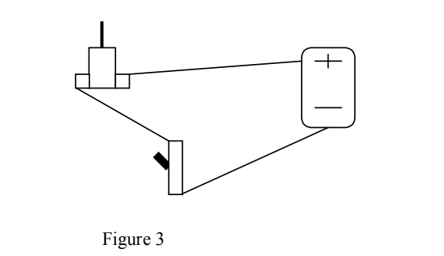

When the switch is off, the circuit is open and electricity can’t flow. When the switch is on, the circuit is closed and electricity can flow. The variables to this design are in chassis length and width, suspension, and placement of the propeller.

Key Concepts and Vocabulary
- Chassis: The base frame of a motor vehicle or other wheeled conveyance
- Suspension: The system of springs and shock absorbers by which a vehicle is cushioned from road conditions.
- Propeller: A mechanical device for propelling a boat or aircraft, consisting of a revolving shaft with two or more broad, angled blades attached to it.
- Series Circuit: The same amount of current flows through all the components placed in it.

Safety Notes
- Caution should be exercised with cutting utensils (scissors, X-acto blade).
- Students should be careful with hot surfaces (glue gun, soldering iron).
- Proper safety procedures and equipment should be used for drill, drill press and belt sander.

